|  |
| --- |
| Functional Design Document |
| CHG213427: |
| TMEC: RI - Enhancements on Contracts & Contract Terms |
| Markets: All - Central Team |
| Release: RLS000700 (Feb’22) |



Contents

A. Document approval 3

B. Revision history 3

1. Business Process Overview 4

1.1 Process Overview 4

1.2 Impact Matrix 4

2. Description of the functional change 5

2.1 Changes in Siebel Sales 5

2.2 English Captions 11

2.3 Changes in the ETL 12

2.3.1. Initial Loads/Massive Data updates 13

2.3.2. Performance test/Indexes creation 13

2.4 Changes in BI 13

2.5 Data Dictionary 14

2.6 Changes in Data Interfaces 14

2.6.1. Inbound 14

2.6.2. Outbound 15

2.6.3. Initial Loads 15

2.6.4. Performance test / Indexes creation 15

2.7 Changes in Batch Processes / Aggregations / DRP 15

2.8 Use Case 16

# Document approval

*List members from market, DBU, BTS, ODC, GTC and other teams that are accountable and responsible for the CHG implementation. Add extra rows if required to include extra team members (e.g. responsible for different areas or services).*

|  |  |  |
| --- | --- | --- |
| Role | Name | Function |
| **DBU Approver** | Sergio Campos | Digital CX Manager |
| **BTS expert** | Iker Fernández | BTS TME Manager & Mobile |
| **BI expert** | Belén Prol | BTS BI Manager |
| **ODC expert** | Ignacio Encinas | ODC Sales |
| **ODC expert** | Miguel Lopez | ODC Data |
| **ODC expert** | Carlos Díaz | Mobile Application |
| **GTC expert** | Jose Carlos Martin | TME Tech Arch Mgr |

This is to confirm that we have reviewed the functional specifications for the proposed solution. We agree with its contents and understand that the technical specifications will be designed based on this approved document.

# Revision history

|  |  |  |  |  |
| --- | --- | --- | --- | --- |
| Revision | Section(s) | Description | Editor | Date |
| 1.0 | - | Draft | Iker Fernández | 09.08.2021 |
| 2.0 | All | Removed Boolean Flag requirement | Iker Fernández | 20.09.2021 |
| 3.0 | All | List Applet instead of MVF | Iker Fernández | 21.09.2021 |
|  |  |  |  |  |
|  |  |  |  |  |
|  |  |  |  |  |
|  |  |  |  |  |
|  |  |  |  |  |

# Business Process Overview

## Process Overview

*Provide brief and meaningful information about the requested change, explain current situation, and estimated future improvements. Use Description, Benefits and Impact provide by market in the CHG.*

With the implementation of TME Connect Reset we want to achieve standardization of the processes and get the integration with a new mobile application. As part of this process following changes need to be included in the Contracts Functionality.

* Include a limit for the negotiation of the contracts.
* Include a Benefit Type to distinguish between Direct Payment, Points or Free Goods.
* Possibility to link a Contract Term to Distribution Products.
* Possibility to link a Contract Term with Incentives products.
* New view or applet for Contract Terms.

**General assumptions:**

## Impact Matrix

|  |  |
| --- | --- |
| GRM Functionality | Contracts |
| Impact Current Functionality? | Yes |
| Markets Affected | All – functionality to be tested only by those where Mobile App is roll-out |
| Applications Affected | Sales / Data |
| Risk of Implementing the change | Low |

# Description of the functional change

## Changes in Siebel Sales

*Explain required changes in Siebel Sales application. Provide names of the views, applets, fields, buttons, etc. Provide screenshots and wireframes of the estimated location for new object or in case of location change.*

Note: Please, notice that the current CHG is not breaking existing functionality of contract/contract templates.

1. **Include a limit for the negotiation of the contracts.**

New fields to be created on **Contract & Contract Template** header: Total Amount Limit & Total Points Limit.

|  |  |  |  |  |  |
| --- | --- | --- | --- | --- | --- |
| **BC** | **Table** | **Field** | **Column** | **Type** | **LOV** |
| JTI JTI Service Agreement | S_DOC_AGREE | JTI Total Amount Limit | X_TOTAL_AMOUNT_LIMIT | Number |  |
| JTI Total Points Limit | X_TOTAL_POINTS_LIMIT | Number |  |

1. **Total Amount Limit.** New numeric field to be included at Contract Template and Contract headers, so that when negotiating the contract, user is not able to exceed this total amount.

Field will be included for the following items:

* Contract Template Header
* Contracts Header (Independent). Not needed for KA or Chain Contracts.
* Optional Field
* Field to be inherited from the Contract Template to the Contract.

Validations:

* Field should always be > 0.
* If this field is informed, there will be a validation so that sum of all contract terms mounts + contract amount (Total Amount calculated field) should never exceed this amount limit. Validation should raise in the backend in the following cases:
  + - * Contract Template: when activating the Contract Template.
      * Contract (Independent): when submitting the Contract for Approval.
    - Validation Message: “Sum of Contract Total Amount exceeds in xxx the Total Amount Limit”
    - i.e. Total Amount Limit: 5000 Euros
      * Contract Amount (Initial Amount) 🡪 1000
      * Contract Term 1 with Amount 🡪 1500
      * Contract Term 2 with Amount 🡪 3000
      * In this case a validation message should be thrown to the user to avoid exceeding this amount. Validation will be raised on backend and mobile app.
      * Validation Message will raise in this way: “Sum of Contract Amount exceeds in 500 the Total Amount Limit”

1. **Total Points Limit.** Similar to above but to limit number of points in the contract. Will also include a validation.
   * + Validation Message: “Sum of Contract Points exceeds in xxx the Total Points Limit”
2. New fields “Total Amount Limit” and “Total Points Limit” to be added to the form applet in the Contract Template applet, see below position:

These fields to be translated only to V1 markets (IT, ES, CZ) so they do not appear for rest of markets. (There is no impact on functionality to expose these fields before V1 go live)

Screen: Data Administration Screen

View: JTI FS Contract Line Items View

Business Object: JTI Template Service Agreement

Applets: Applet[0]: JTI Template Contract Detail Applet-Cloned; Applet[1]: JTI FS Contract Item List Applet;

Business Components: BusComp[0]: JTI Template Service Agreement; BusComp[1]: JTI Contract Agreement Item;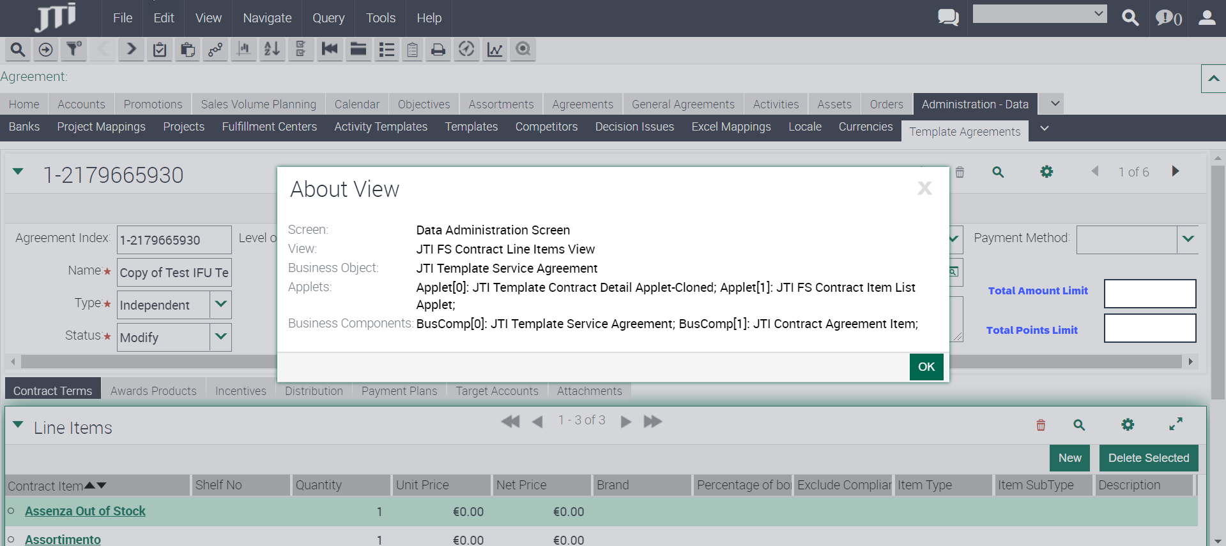

1. New fields “Total Amount Limit” and “Total Points Limit” to be added to the form applet in the Contract form applet, in the Show More section see below position: To be shown in read only mode.

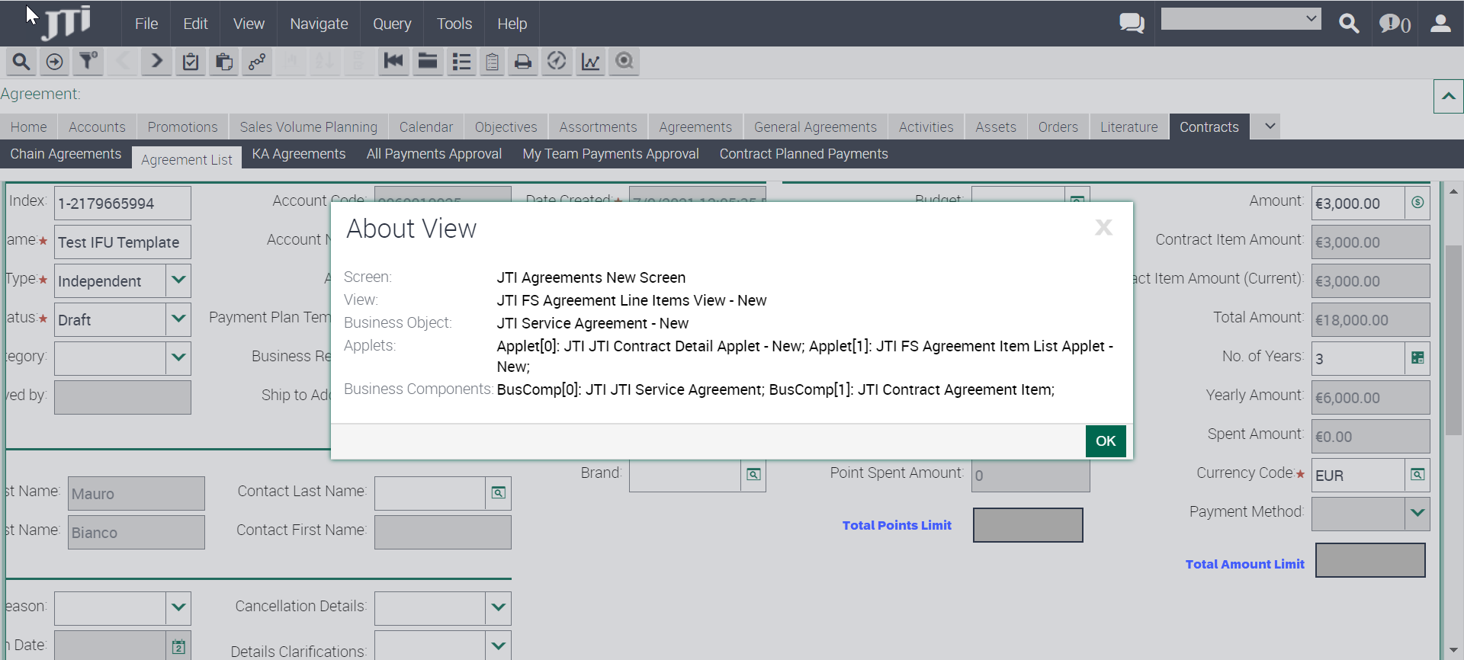

Screen: JTI Agreements New Screen

View: JTI FS Agreement Line Items View - New

Business Object: JTI Service Agreement - New

Applets: Applet[0]: JTI JTI Contract Detail Applet - New; Applet[1]: JTI FS Agreement Item List Applet - New;

Business Components: BusComp[0]: JTI JTI Service Agreement; BusComp[1]: JTI Contract Agreement Item;

1. **Include a new field Benefit Type**

New Field to be created on **Contract Terms** under Contract and Contract Template:

Field should be properly inherited when deploying a contract from a template, renewing and copying a contract.

* **Benefit type** 🡪 New LOV field to specify type of benefit given. (Payment, Points, Free Goods)
  + Required for TME Connect Markets.
  + Following fields will become editable/ro based on this logic:
    - Unit Price (Editable when Benefit Type = Direct Payment)
    - Net Price (Editable when Benefit Type = Direct Payment)
    - Nb of Points (Editable when Benefit Type = Points)

|  |  |  |  |  |  |
| --- | --- | --- | --- | --- | --- |
| **BC** | **Table** | **Field** | **Column** | **Type** | **LOV** |
| JTI Contract Agreement Item | S_AGREE_ITEM | Benefit Type | X_BENEFIT_TYPE | LOV | JTI_BENEFIT_TYPE |

* A new LOV should be created to store the information related to the benefit type. Values will be provided by markets in next releases.

|  |  |  |  |  |
| --- | --- | --- | --- | --- |
| **LOV** | **LIC** | **Value** | **Language** | **Organization** |
| JTI_BENEFIT_TYPE | Payment | Payment | ENU | All |
| JTI_BENEFIT_TYPE | Points | Points | ENU | All |
| JTI_BENEFIT_TYPE | Payment | Pago | ESN | Spain |
| JTI_BENEFIT_TYPE | Payment | Pagamento | ITA | Italy |
| JTI_BENEFIT_TYPE | Payment | ? | CSY | Czech |

**New fields should be included for Contract Template and Contracts, to ensure following logic can be kept:**

As this requirement has impact on current markets, it should be ensured that functionality is enabled/disabled for TME Connect markets as part of the roll-out. (i.e. Hide/Show applet based on configuration)

* Making Benefit Type mandatory only for this view. Contract Template & Contract.
* Setup the logic for the Price, Nb of Points and Free Goods, based on the Benefit Type.
* Fields to be displayed for the new copies of following applets:
  + - Contract – Contract Terms (JTI FS Agreement Item List Applet New)
    - Contract Template – Contract Terms: (JTI FS Contract Item List Applet)
  + Contract Item
  + Quantity
  + Benefit Type
  + Unit Price (Editable when Benefit Type = Direct Payment)
  + Net Price (Editable when Benefit Type = Direct Payment)
  + Nb of Points (Editable when Benefit Type = Points)
  + Exclude Compliance
  + Read Only
  + JTI Audit Sequence
  + Distribution

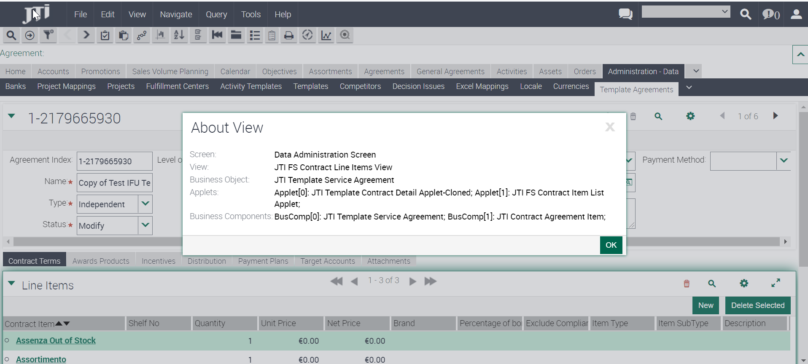

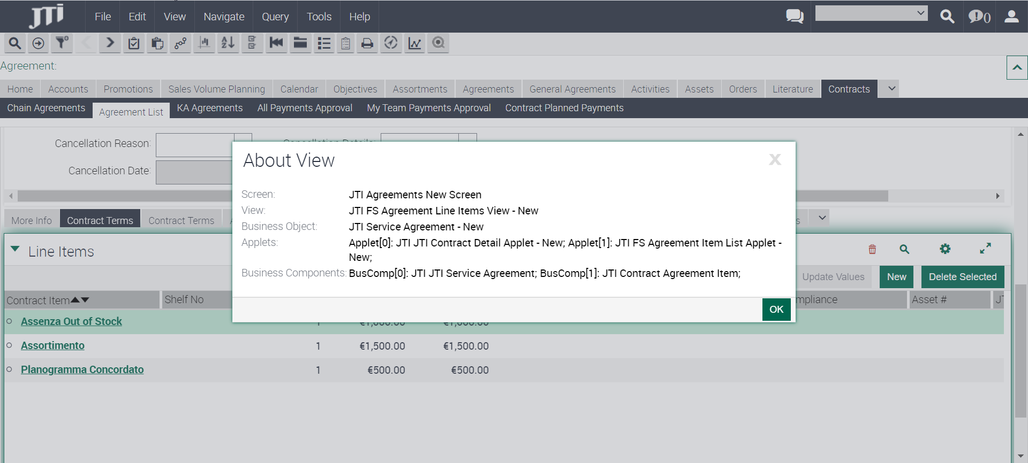

1. **Possibility to link a Contract Term to Distribution Products & Incentives.**
2. **Distribution Enhancements:**
   1. **Include Distribution applet** below Contract Template – Contract Terms and Contract – Contract Terms screens, so it should be possible to add the Distribution products linked directly to the selected contract term.

This applet should be similar to the existing “**Distribution”** applet in the distribution tab.

To be included in the following views:

* + - * JTI FS Contract Line Items View;
      * JTI FS Agreement Line Items View – New;

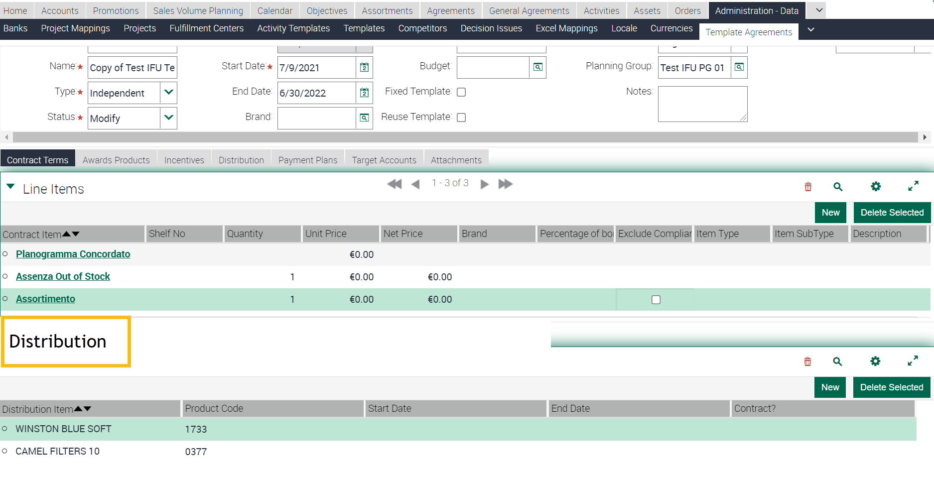

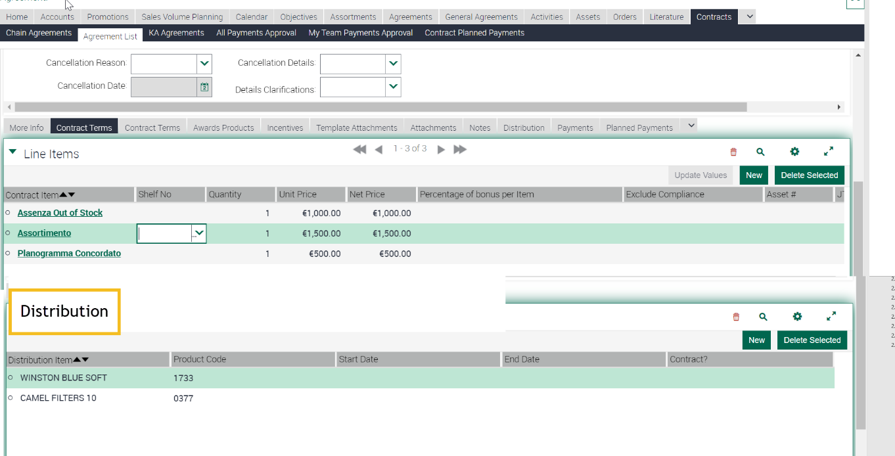

Applet to be shown only to V1 markets (IT, ES, CZ) so they do not appear for rest of markets. (There is no impact on functionality to expose these fields before V1 go live)

* 1. As well new field **Contract Term ID will be needed in the Distribution BC**, to be able to link distribution products to an specific contract term.
  2. New joined field Contract Term in the Distribution list to display the name of the contract term.
     1. To be included in both Template Agreements – Distribution and Agreements – Distribution.
        + JTI FS Distribution Item List Applet;
        + JTI FS Distribution Item List Applet - New;

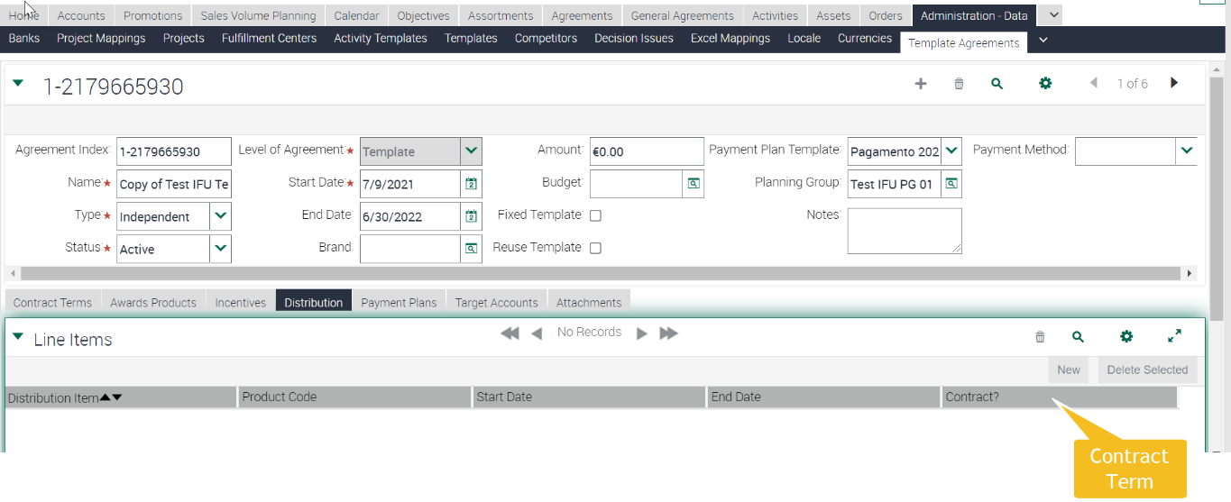

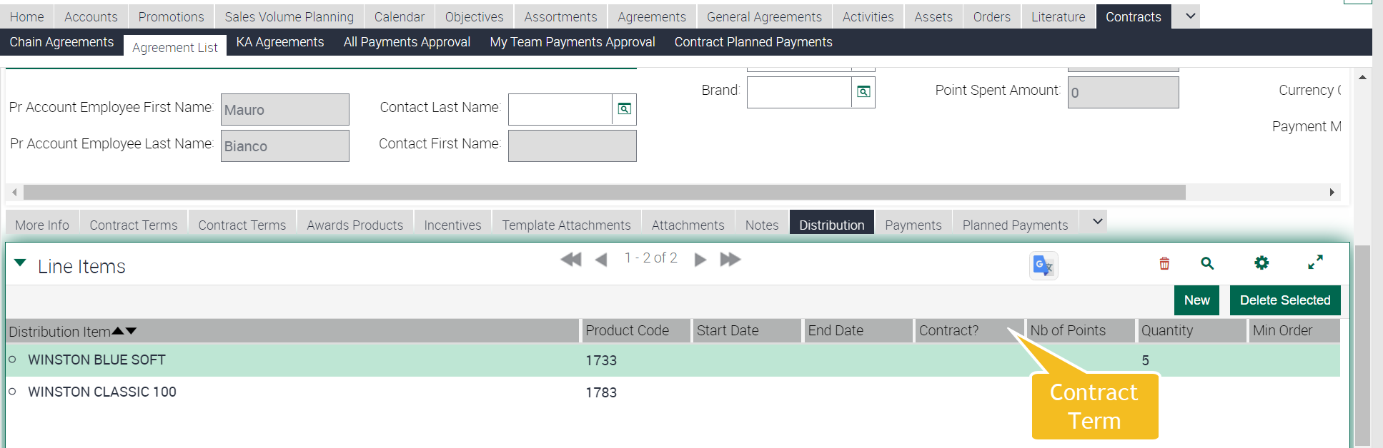

These fields to be translated only to V1 markets (IT, ES, CZ) so they do not appear for rest of markets. (There is no impact on functionality to expose these fields before V1 go live)

1. **Incentives Enhancements:**
   1. New field **Contract Term ID**, to be able to link incentives to an specific contract term.
   2. New joined field Contract Term to display the name of the term.
      1. To be included in both Template Agreements – Incentives and Agreements – Incentives.
         * JTI JTI FS Agreement Incentive Applet;

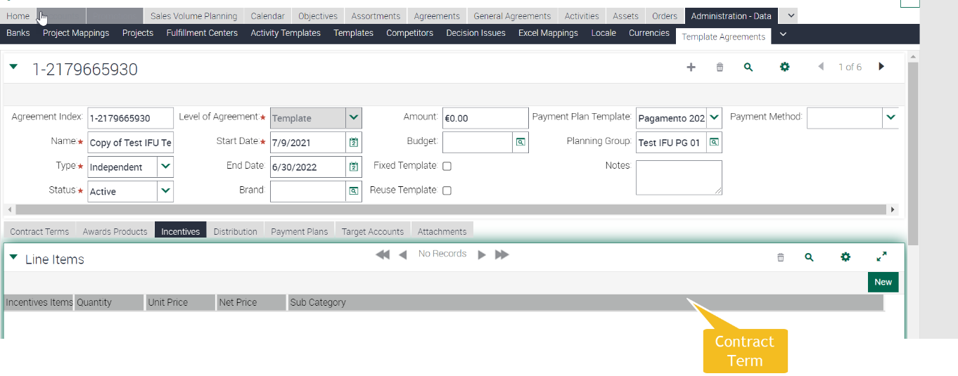

This field to be translated only to V1 markets (IT, ES, CZ) so they do not appear for rest of markets. (There is no impact on functionality to expose these fields before V1 go live)

|  |  |  |  |  |  |
| --- | --- | --- | --- | --- | --- |
| **BC** | **Table** | **Field** | **Column** | **Type** | **LOV** |
| JTI Contract Agreement Item |  | Contract Term | Join field |  |  |
| JTI Contract Agreement Item | S_AGREE_ITEM | Contract Term ID |  |  |  |
| JTI JTI Agreement Incentives | S_AGREE_ITEM | Contract Term ID | TBD |  |  |

## English Captions

|  |  |  |  |  |
| --- | --- | --- | --- | --- |
| Type | Format | Caption ENU | Language | Caption LOCAL |
| JTI Total Amount Limit | Number | Total Amount Limit | ENU |  |
| JTI Total Amount Limit | Number | Total Amount Limit | ITA | Limite importo |
| JTI Total Amount Limit | Number | Total Amount Limit | CSY | TBD |
| JTI Total Amount Limit | Error message | Sum of Contract Total Amount exceeds in xxx the Total Amount Limit | ENU |  |
| JTI Total Amount Limit | Error message | Sum of Contract Total Amount exceeds in xxx the Total Amount Limit | ITA | TBD |
| JTI Total Amount Limit | Error message | Sum of Contract Total Amount exceeds in xxx the Total Amount Limit | CSY | TBD |
| JTI Total Points Limit | Error message | Sum of Contract Total Points exceeds in xxx the Total Points Limit | ENU |  |
| Contract Term | Text | Contract Term | ENU |  |
| Contract Term | Text | Contract Term | ITA | Clausola |
| Contract Term | Text | Contract Term | ESN | Contract Term |
| Contract Term | Text | Contract Term | CSY | TBD |
| Benefit Type | Picklist | Benefit Type | ENU |  |
| Benefit Type | Picklist | Benefit Type | ITA | Nazione |
| Benefit Type | Picklist | Benefit Type | ESN | Tipo Benefit |
| Benefit Type | Picklist | Benefit Type | CSY | *TBD* |

## Changes in the ETL

* *Functionally explain the general ETL requirements, listing in the below table all the fields required to be moved to OLAP, using ENU labels if coming from Sales Application views.*
* *If not present already in the TME Sales section, application print screens are required.*
* *Hidden fields technically needed by the ETL (e.g. Ids, Foreign Keys) do not have to be listed down*
* *It is however crucial that all fields functionally required are listed and that help is offered for Technical Teams to derive the correct implementation in terms of transformation/logic.*
  + *Please clarify needed transformations (IF NULL SET to 0) or calculations (complex logic)*
  + *Any filtering required at extraction or inserting time.*
* *Kindly combine the info in the below table with written requirements to clarify the requirements.*
* For TME Connect, the analytic platform will be Power BI, so changes for the ETL are also related to the PBI transfer instead of OBIEE.
* Fields must be included on the ETL process to transfer the fields to PBI:

|  |  |  |  |  |  |
| --- | --- | --- | --- | --- | --- |
|  | OLTP Source | | ETL | OLAP Target | |
| # | **Entity** | **Attribute** | **Transformation** | **Entity** | **Attribute** |
|  | Contract Terms | Benefit Type | TBD | Contract Term | Benefit Type |
|  | Incentives | Contract Term ID |  |  |  |
|  | Distribution | Contract Term ID |  |  |  |

* Please, perform assessment of possible impact on the ETL/BI process for those fields to be decommissioned.

## Initial Loads/Massive Data updates

* *Use the below table to specify the requirements for data updates:*
* *Please help to clarify filters by market, period, or other attribute (in the remarks column).*
* *A data update’s urgency is dependent on the fact an impacted field in the update is used in Siebel Sales or OBIEE application logic. In case so, it will be defined as urgent and the update will be done immediately after the technical release, ideally during the outage.*

|  |  |  |  |  |  |
| --- | --- | --- | --- | --- | --- |
| Data Update | | | | | |
| # | **Entity** | **Markets** | **Periods** | **Urgent (ODC)** | **Remarks** |
|  | Contract Term | TME Connect Markets (IT, SP, CZ) |  |  | Update Benefit Type to Payment. |
|  |  |  |  |  |  |

*\*In case TME Sales or BI application logic relies on the data update, this must be set as urgent.*

## Performance test/Indexes creation

* *It is assumed that ETL Performance Analysis and optimization will be done in all cases which require it, especially in brand new tables. Please note BI performance optimization is not subject of this analysis. If it applies, list down the requirements / newly developed areas that require a performance test with reasonable volume.*

N/A

## Changes in BI

*It is mandatory to include examples of the reports that are expected using the new metrics/objects that will be created. These reports are needed to validate that the technical solution will cover the requirements and later to test the development.*

* ***For new metrics****, it is needed to include an example (attached to doc).* 
  + *The steps are: create one report with existing data and include the XML; export the data to Excel and include the new metrics as fields calculated in Excel itself. The calculated fields will be used to validate the values obtained with the new metrics in DEV and UAT.*
  + *If the new metric requested can currently be calculated in the report, it is also useful to have the current formula included in the report for validation.*
  + *Also see an example copied at the end of this email where the new columns were added as literals in the report to show where they would be.*
* ***For new fact tables and/or dimensions****, it is needed to specify which other existing fact tables and dimensions are expected to be used together with the new objects. This is what we call “cross fact analysis”.* 
  + *Example: new Fact – Contracted Vending Machine Compliance. Market could require mixing this new fact with Fact – Contract Vending Machine, Fact – Contract Vending Machine Labels, Fact – Contract and dimensions Contract, Label Products, etc.*
  + *This is extremely important because we can’t guarantee that the new objects will work with existing objects if this was not explicitly requested in the FD. In case the market requests new cross fact analysis later, it will be considered a new requirement and will be subject to risk analysis and release timing. If raised late or has high risk, would be left for the next release.*
* ***For new cross fact analysis related to existing objects****, it is needed to generate an example with similar format as the one attached. Create reports with the existing functionality, show the result returned currently (include XML), export it to Excel and create there the report expected after the CR implementation, putting the different pieces together.*

|  |  |
| --- | --- |
| Field Name | Changes in BI |
| Benefit Type | Have to be available at Contract Term entity to be included in their reports.  No specific metric is required for them. |

## Data Dictionary

*New fields in BI should be added to the Data Dictionary. Actions below should be done:*

* *Business Description of the new fields (BTS TME) must be provided in this section.*
* *Fields should be added to the Data Dictionary DB Tables (ODC)*

Please, add next fields to the Data Dictionary:

|  |  |
| --- | --- |
| Field Name | Description |
| Total Amount Limit | It indicates which is the limit amount for direct payment that a sales rep can negotiates in a contract. |
| Total Points Limit | It indicates which is the limit amount of points that a sales rep can negotiates in a contract. |
| Benefit Type | It indicates the type of benefit that will be given to the retailer when meeting the contract term. i.e. Payment, Points, Free Goods, etc. |

## Changes in Data Interfaces

*Populate the below table with the information of the new inbound/outbound Interfaces requested, specifying:*

* *OLTP or OLAP | Entity | Interface Code*
* *Fields requested (or new fields to be added in new version)*
* *Explain the logic behind each field, if there are any remarks about its incoming format, required transformations, data type (to keep this simple, we use String, Number, Date, Datetime, Time, LOV)*
* *Add extra information about schedule (Nightly ETL, One-time, other custom schedule) in this section.*
* *For Outbound interfaces add Business Rules:* 
  + *specify the source system conditions for a record to be exported*
  + *specify the post-export actions required to set records as exported*
* *Repeat this information for each interface, do not mix requirements.*
* *Combine the info in the below table with written requirements to clarify the requirements.*
* *Ensure you add a note in FD in case a new OLTP Interface may have impact in Siebel Remote Transaction Backlog, so that Technical Teams consider the risk in the design. Anything that will massively update or insert in OLTP is a risk for Transaction Backlog. As well, please consider a massive execution of the new process in the Use Case section, as this will be replicated in the CHG’s Test Script.*

## Inbound

|  |  |  |  |  |  |
| --- | --- | --- | --- | --- | --- |
| *OLTP Contract Header - CH* | | | | | |
| **#** | **Entity** | **Field Name** | **Contents** | **Data type/format** | **Transformation** |
| 29 | Contract Header | Total Amount Limit |  | Number |  |

|  |  |  |  |  |  |
| --- | --- | --- | --- | --- | --- |
| *OLTP Contract Terms - CT* | | | | | |
| **#** | **Entity** | **Field Name** | **Contents** | **Data type/format** | **Transformation** |
| 29 | Contract Term | Benefit Type |  | LOV |  |
|  | Distribution | Contract Term Id |  |  |  |
|  | Incentives | Contract Term Id |  |  |  |

## Outbound

|  |  |  |  |  |  |  |
| --- | --- | --- | --- | --- | --- | --- |
| *N/A* | | | | | | |
| # | **Entity** | **Field Name** | **Contents** | **Data type/format** | | **Transformation** |
| # |  |  |  |  |  | |

## Initial Loads

*Specify requirements for initial data loads if required.*

**N/A**

## Performance test / Indexes creation

*Specify requirements for performance test or indexes creation if required.*

**N/A**

## Changes in Batch Processes / Aggregations / DRP

*This section will be used for specifying requirements different to pure ETL tasks or Inbound or Outbound interfaces. It is assumed that these processes are not trivial and require transforming data in a complex way. Therefore, functionality will be explained by means of*

* *List of written requirements, in case requirements are not too complex and their written specification is not vague*
* *Pseudo-code / basic flowchart diagram (available in every Visio installation)*
* *A combination of both*
* *Always using ENU Names of TME Sales or OBIEE application fields and agreed entity names as per TME ENU application or OBIEE subject areas.*
* *Please ensure you add a note in FD in case a new OLTP Batch may have impact in Siebel Remote Transaction Backlog, so that Technical Teams consider the risk in the design. Anything that will massively update or insert in OLTP is a risk for Transaction Backlog. As well, please consider a massive execution of the new process in the Use Case section, as this will be replicated in the CHG’s Test Script.*

**N/A**

## Use Case

|  |  |  |
| --- | --- | --- |
| Role  *Trade Marketer, ASM, Local Admin…* | Application  *Sales, Analytics, ETL, Batch, Interface* | Step  *Description of the step and its expected output* |
| Local Admin | Siebel Sales | **Contract Template Header:**  Create a new contract template.  Include a Planning Group.  Set the field Total Amount Limit to 5000.  Set the field Total Points Limit to 200.  Include new contract term. Following functionality should be enabled only for TMEC markets:   * Ensure that Benefit Type is mandatory * Target field should be null by default on this view. * When selecting a Benefit Type, ensure following logic is implemented:   + Unit Price (Editable when Benefit Type = Direct Payment)   + Net Price (Editable when Benefit Type = Direct Payment)   + Nb of Points (Editable when Benefit Type = Points) |
| Local Admin | Siebel Sales | **Validate Total Amount Limit:**  Inform the following fields:   * Total Amount Limit: 5000 Euros * Contract Amount (Initial Amount) 🡪 1000 * Contract Term 1 with Amount 🡪 1500 * Contract Term 2 with Amount 🡪 3000   When trying to save:  Validation Message will raise in this way: “Sum of Contract Amount exceeds in 500 the Total Amount Limit” |
| Local Admin | Siebel Sales | **Validate Total Points Limit:**  Inform the following fields:   * Total Points Limit: 200 Points * Points Amount (Initial Amount) 🡪 50 * Contract Term 3 🡪 150 Points * Contract Term 4 🡪 100 Points   When trying to save:  Validation Message will raise in this way: “Sum of Points Amount exceeds in 50 the Total Points Limit” |
| Local Admin | Siebel Sales | **Product Distribution:**  Include several Distribution products, by using new Distribution applet. (Ensure add/remove is possible, and searching)  Then navigate to Distribution tab, and review that products are properly created and linked to the contract term specified.  Activate the Agreement Template |
| Local Admin | Siebel Sales | **Deploy Contract from Template:**  Deploy a Contract from previous activated template.  Review that logic on Benefit Type is still valid.  Review that validation for Total Amount Limit and Total Points Limit is still valid.  Review that Distribution can be updated from the Contract Terms view. |
| Local Admin | Siebel Sales | **Deploy Contract without Template:**  Deploy a Contract.  Review that logic on Benefit Type is still valid.  Review that validation for Total Amount Limit and Total Points Limit is still valid.  Review that Distribution can be updated from the Contract Terms view. |
| Local Admin | Inbound CH interface / ETL | Provide a flat file to upload contract header, include values for “Total Amount Limit”, “Total Points Limit”  Place the CH flat file on the IUNP folder (SSIS console).  Wait nightly upload of the files and the ETL process.  Verify next day that the contracts are properly uploaded and available at Siebel Sales. |
| Local Admin | Inbound CT interface / ETL | Provide a flat file to upload contract terms, include values for “Benefit Type”  “Contract Term” for Distribution/Incentives records  Place the CT flat file on the IUNP folder (SSIS console).  Wait nightly upload of the files and the ETL process.  Verify next day that the contract terms are properly uploaded and available at Siebel Sales. |